MED D - Test Claim - Calculating Quantity of Packaged Medication General Information

Identify Packaged Medication
General Formula
General Formula Step by Step Process
Related Documents

Description: This document provides general information regarding calculating quantities of packaged medications.

Identify Packaged Medication
To help users recognize test claims for packaged medications that require additional calculations, a message will display on the Test Claim screen in PeopleSafe. When users select a packaged medication, the following message will display next to the quantity box fields:

This is a packaged medication. To calculate quantity: Determine the number of packages needed and multiply that by the package size.

Example:

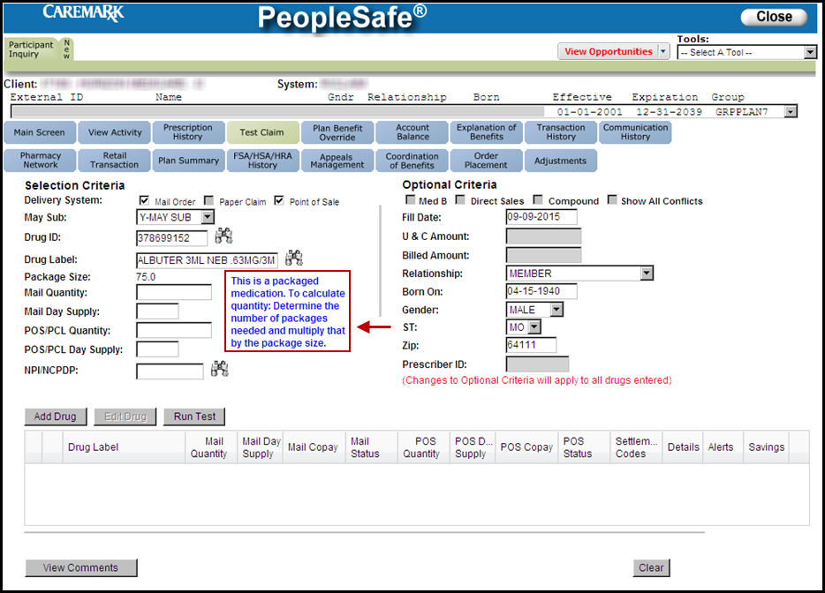

Notes:
- The message will not appear when users populate a test claim from an existing claim.
- Because of the way various drugs are loaded into our applications, this message will not show in 100% of packaged medication scenarios. Additionally, some drugs are considered “packaged” but are able to be broken up in individual units either at the Mail or Retail pharmacy (Example: Lancets). In these scenarios the help text will not be displayed.

Top of the Document

General Formula
Note: For assistance in determining the below values, refer to Calculating Quantities for Packaged Medication worksheet.

Units Per Day | X | Days | = | Units Needed

Units Needed | ÷ | Usage Quantity Package  (from PeopleSafe) | = | Total Packages Needed

Total Packages Needed | X | Package Size  (from PeopleSafe) | = | Test Claim Quantity

Contact Clinical Care Services for assistance when:
- The Usage QTY Pkg is NOT listed on the Drug Details screen in PeopleSafe
- You are unsure of the quantity needed

Top of the Document

General Formula Step by Step Process
Perform the steps below to run a test claim for a packaged medication:
DO NOT use the following steps for Ointments, Creams, Grains or Liquids; refer to Creams, Lotions and Ointments, Grains, Liquids for further details.
Step | Action
1 | Determine how many total uses are needed per day.  Example: One eye drop in each eye once daily = 2 drops per day
2 | Determine how many total uses are needed for the Day Supply.  Example: Caller is requesting price for a 3 month supply  2 drops per day X 90 day supply = 180 drops for a 90 Day Supply
3 | Click on the Drug ID link for the specific strength of the medication.  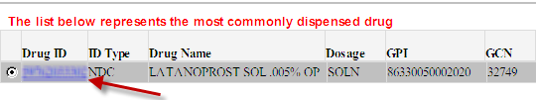  Result: The Drug Details screen displays.
4 | Divide total uses needed for Day Supply by the “Usage Qty Pkg” and if result is not a whole number round up.  Exception: If result is not a whole number round down for Controlled Substances, Topical Agents, and Non-Diabetic Unbreakable Injectables  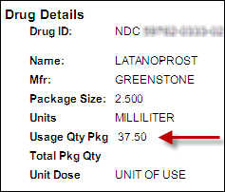  Example: 180 drops / 37.5 = 4.8  If there is NOT a Usage QTY Pkg listed on the Drug Details screen in PeopleSafe, contact Clinical Care and they can inform you how many uses are contained within the packaged medication.
5 | Multiply the total number of packages needed by the Package Size.  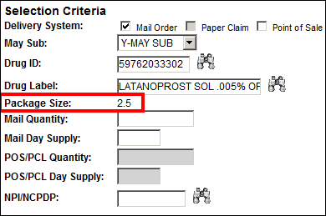
6 | Enter the answer from Step 5 as the Quantity for the Price Estimate.  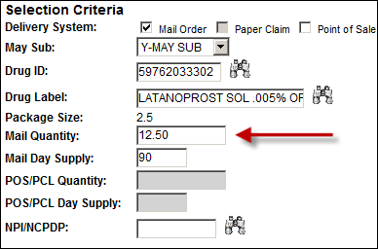

Top of the Document

Related Documents
MED D - Test Claim Index

Parent SOP: CALL-0049: Customer Care Internal and External Call Handling
Abbreviations / Definitions: Customer Care Abbreviations, Definitions, and Terms

Top of the Document

Not To Be Reproduced Or Disclosed to Others Without Prior Written Approval
ELECTRONIC DATA = OFFICIAL VERSION – PAPER COPY – INFORMATIONAL ONLY

